Thank you for interest in our company!

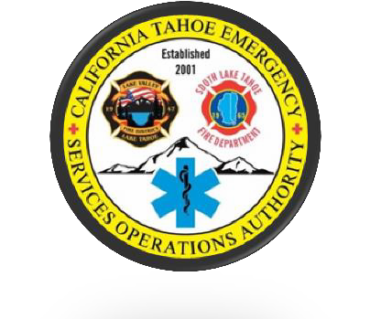

**Cal Tahoe Emergency Services Operations Authority**

Please submit a completed application, resume, and cover letter (optional) to our Office Administrator, Kayla Galvan, via email at [kgalinskictjpa@gmail.com](mailto:kgalinskictjpa@gmail.com).

Once your resume and application are received, you will receive a confirmation email. During active hiring, you will be contacted within two weeks to schedule an interview. Your resume will be kept on file for six months in case of future openings. If you have any questions, please use the email above.

We look forward to hearing from you!

The CTESOA Team