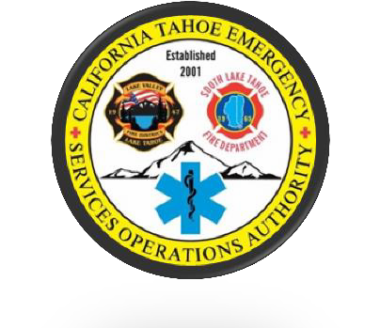

Cal Tahoe Emergency Services Operations Authority

JPA Board of Directors
Special Meeting
Monday May 24, 2021 5:00pm
Zoom Virtual Meeting

Minutes

I. Special Meeting- Call to Order/ Roll Call/ Pledge of Allegiance
A. Chairperson Wallace Called the Meeting to Order at 1:01 pm
C. Board Attendees
- Tamara Wallace, Chairperson
- Mike Cathcart, Vice Chair
- Leona Allen, Director

Other Attendees
- Ryan Wagoner, CTESOA Executive Director
- Kayla Galvan, CTESOA
- Aimee Treutlein, CTESOA
- Nick Clair, Attorney
- Brad Zlendick, LVFD
- Steve Pevenage, LVFD
- Gary Gerren, FLLF
- Paula Peterson, South Tahoe Now

Communications from the Audience on Non Agenda Items.
None.
Public’s Chance to speak on any Non-Agenda Items.
None.

D. Note about California’s Open Meeting Law

- Approval of Agenda
Director Allen moves to approve the Agenda. Director Cathcart seconds. No Further discussion. Director Wallace votes Aye, Director Allen votes Aye, Director Cathcart votes Aye. Motion carries unanimously.

- Approval of the Minutes from April 22, 2021

Director Cathcart moves to approve the minutes from April 22, 2021. Director Allen seconds. No Further discussion. Director Wallace votes Aye, Director Allen votes Aye, Director Cathcart votes Aye. Motion carries unanimously.

- Delegation Resolution for County Services RFP.

Executive Director Wagoner states as part of the RFP process the Board needs to authorize the resolution in order to submit the RFP Proposal, which was reviewed by the Ad Hoc Committee. Director Cathcart moves to approve the resolution. Director Allen seconds. Director Wallace votes Aye, Director Allen votes Aye, Director Cathcart votes Aye. Motion carries unanimously.

D. Adjournment
Chairperson Wallace adjourns the meeting at 5:11pm.

