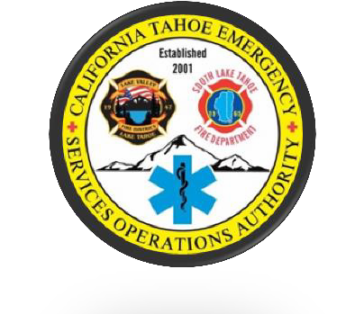

Cal Tahoe Emergency Services Operations Authority

JPA Board of Directors
Special Meeting
Monday, March 29, 2021 12:00pm
Zoom Virtual Meeting

Minutes

I. Special Meeting- Call to Order/ Roll Call/ Pledge of Allegiance
A. Chairperson Wallace Called the Meeting to Order at 12:00 pm
C. Board Attendees
- Tamara Wallace, Chairperson
- Mike Cathcart, Vice Chair
- Leona Allen, Director
- John Rice, Director
- Cody Bass, Director

Other Attendees
- Ryan Wagoner, CTESOA Executive Director
- Kayla Galvan, CTESOA
- Steve Pevenage, LVFD
- Nick Clair, Attorney
- Fawna Cheney, Treasurer
- Brooke Martone, Monarch Architecture
- Gary Gerren, FLLF
- Bernie Cullen, San Patricio Construction

Communications from the Audience on Non Agenda Items.
None.
Public’s Chance to speak on any Non-Agenda Items.
None.

D. Note about California’s Open Meeting Law

- Approval of Agenda
Executive Director Wagoner suggests having discussion to postpone the next regularly scheduled meeting. Director Rice moves to approve the agenda. Director Bass seconds. No further discussion. Director Wallace votes Aye, Director Allen votes Aye, Director Cathcart votes Aye, Director Rice votes Aye, Director Bass votes Aye. Motion carries unanimously.

- Approval of the Minutes from January 11, 2021
Director Allen makes note of a spelling correction. Director Rice moves to approve the minutes from January 11, 2021. Director Bass seconds. No Further discussion. Director Wallace votes Aye, Director Allen votes Aye, Director Cathcart votes Aye, Director Rice votes Aye, Director Bass votes Aye. Motion carries unanimously.

- Construction Project Agreement

Executive Director Wagoner recaps that at the last meeting the Board gave direction to do evaluative engineering, then the project was re-posted for bids. Brooke Martone explains that two plans were offered and that San Patricio was able to bid $517,000 for the original scope which is more extensive than the alternate plan. Executive Director Wagoner states that this is for the first phase of construction, and a second phase will be required in the future to bring the building up to code for an essential services building. Director Bass asks if this agreement will satisfy the requirement from the City that plans need to be submitted by September. Executive Director Wagoner explains that the requirement with the City is that plans to bring the building the up to essential service code must be submitted by September, which he and the Architect will be working on soon. He states that under the American Rescue Plan, funds can be used for infrastructure and he hopes the JPA will be able to use those funds from the County for phase 2 of construction. Director Bass states he supports rebuilding the fire stations and putting the JPA in a separate area of Station 2. Director Allen moves to approve the agreement between CTESOA and San Patricio Construction. Director Bass seconds. No further discussion. Director Wallace votes Aye, Director Allen votes Aye, Director Cathcart votes Aye, Director Rice votes Aye, Director Bass votes Aye. Motion carries unanimously.

The board agrees to postpone the next regularly scheduled meeting.
Bernie Cullen states that once all the paperwork is settled they will begin working on the project.

D. Adjournment
Chairperson Wallace adjourns the meeting at 12:44 pm.

